Massive rotator cuff tears can occur as a result of prolonged overuse, wear and tear, trauma, or even surgery. This may cause you pain and mean you are no longer able to easily lift your arm. The Deltoid is a powerful muscle on the outside of your arm that can be re-educated to compensate for the rotator cuff.

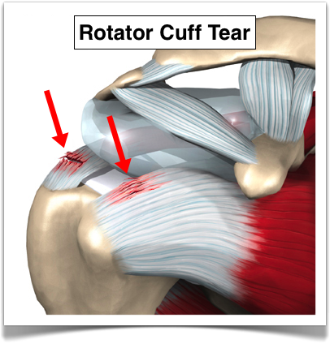

The following exercises are a 10 stage non-operative programme for the management of massive rotator cuff tears.

**Exercises should be** **done two to three times a day** to strengthen your deltoid muscle and gain full benefit. **Aiming for 10 repetitions.** These exercises must be done for **at least 12 weeks** and must always be performed starting lying down to begin with.

Your therapist will guide you depending on your symptoms and response

**Stage 1.**

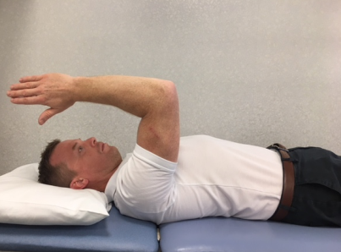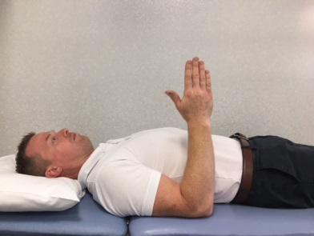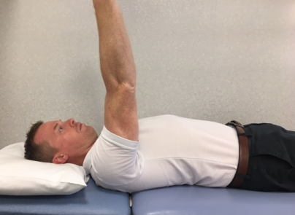

1

Lying on your back with your arms by your side, bend your elbow on your affected side to 90 degrees, then lift the elbow off the bed towards the ceiling. When upper arm is vertical straighten your elbow. When you have lifted the arm as high as you can, slowly bend the elbow and return the arm to the bed, as controlled as possible.

**Stage 2.**

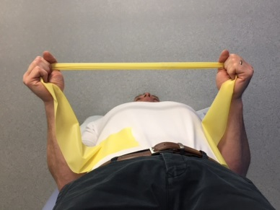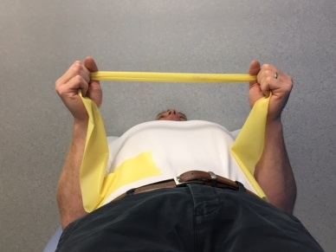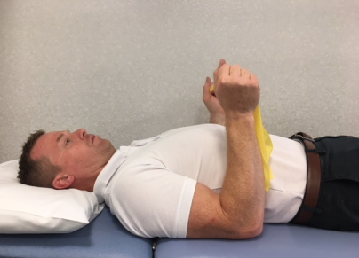

You will need a yellow resistance band. Lying on your back with your arms by your side, bend your elbows to right angles holding the resistance band. Take your hand on the affected side out to the side. Then control back to the middle.

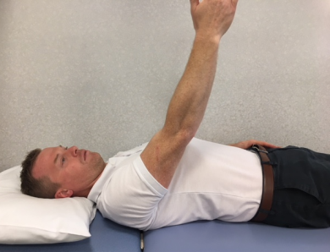**Stage 3.**

Start as if you were doing stage 1, once the arm is fully straight add a small swaying movement away from, and towards the head. When finished, bend the elbow and return the arm back to the bed in a slow and controlled manner.

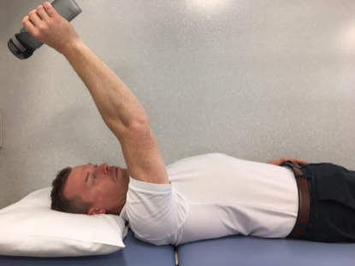**Stage 4.**

Repeat stage 3. Holding a bottle with a small amount of water to increase resistance.

**Stage 5.**

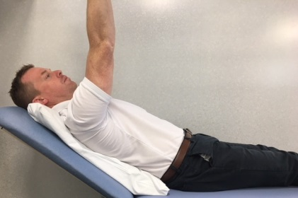Activities in stages 1 – 4 repeated with head of bed progressively raised.

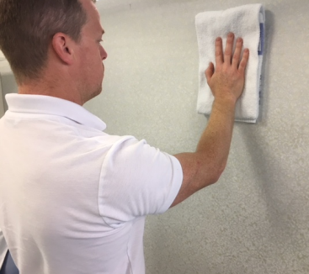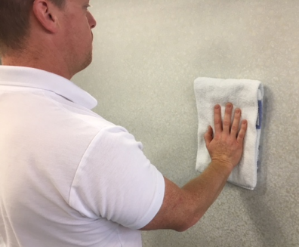**Stage 6.**

Stand facing a wall with a cloth in your affected hand. Keeping as much pressure through your hand, slide it up the wall. At the top, hold for a few seconds and try to increase stretch with unaffected side supporting. Lower arm back down keeping pressure through hand, in a slow and controlled manner.

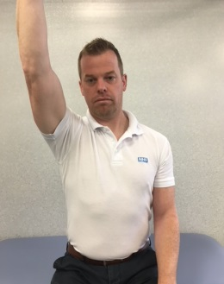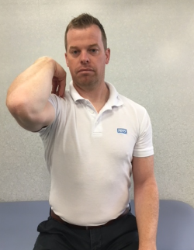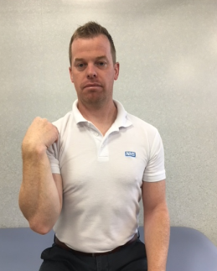**Stage 7.**

Sit down and bend your elbow of the affected arm so that the hand is close to the shoulder. Reach the arm up until the elbow is pointing towards the ceiling, then straighten the arm. Slowly reverse the movement and control the arm back down to your side.

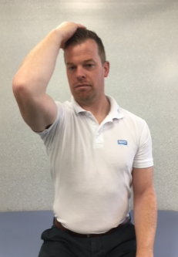

**Stage 8.**

Repeat as Stage 7. Then lower your hand to touch your head and straighten your elbow again. Repeat 2-3 times before slowly lowering your arm back to your side keeping elbow bent.

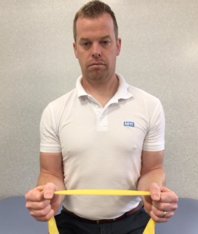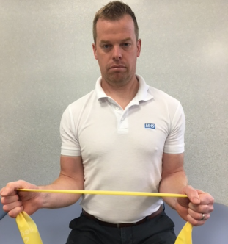**Stage 9.**

Sitting with your elbows bent and in to your sides holding a yellow resistance band. Take the affected side away from your body as far as you are able. Slowly return to the starting position as controlled as possible.

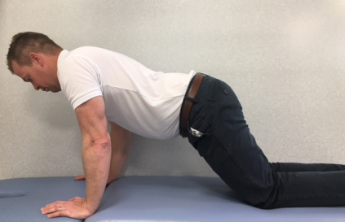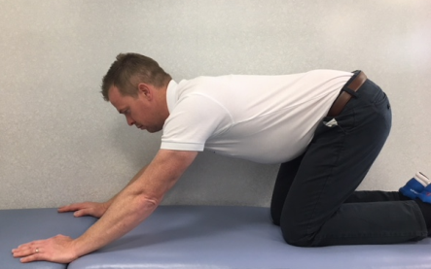**Stage 10.**

In 4 point kneeling transferring weight forwards and backwards.

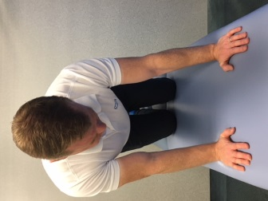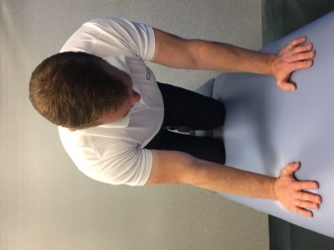

In 4 point kneeling transferring weight side to side

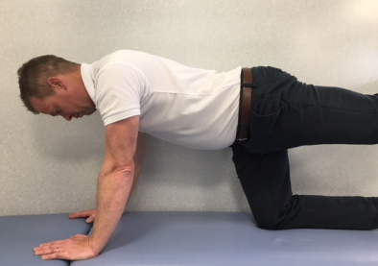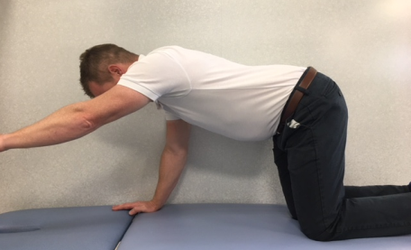

In 4 point kneeling progress by either lifting a leg or an arm. Remember to keep your back still.

For accompanying videos to these exercises, please follow the link below

<https://www.torbayandsouthdevon.nhs.uk/services/physiotherapy/support-videos/torbay-shoulder-exercise-programme/>

**References**

1. The Torbay protocol. https://www.shoulderdoc.co.uk/article/1028 [online 12-5-16]
2. The Torbay protocol. Ainsworth. B (http://bristolshoulderandelbowsurgery.co.uk/shoulder-surgery-rehabilitation-guidelines/deltoid-torbay-rotator-cuff-rehabilitation/ [online 12-5-16]
3. Ainsworth. B (2006) Physiotherapy rehabilitation in patients with massive, irreparable rotator cuff tears. Musculoskeletal care. Volume 4 Issue 3 pages 140-151, Sept 2006.
4. Gerber C, Wirth S, Farshad M (2011) Treatment option for massive rotator cuff tears. J Shoulder Elbow Surg (2011) 20: S20-S29.
5. Image http://rwwcomplaw.com/wp-content/uploads/2014/07/rotator-cuff-tear-illustration.png [online 12-5-16]

**Contact details**

The Health Information Centre

Poole Hospital NHS Foundation Trust

Longfleet Road, Poole, Dorset

BH15 2JB

Telephone: 01202 448003

[**www.poole.nhs.uk**](http://www.poole.nhs.uk/) Author: Andy Hayward.