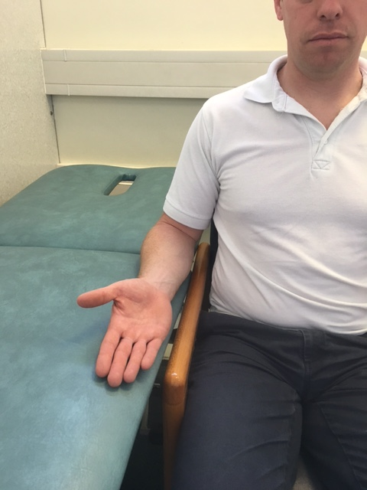
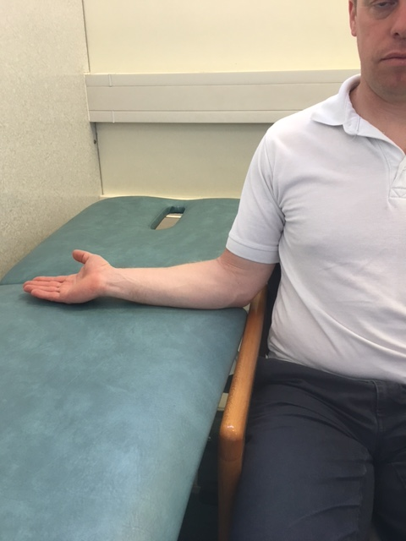

In sitting, support your elbow on a table or other surface. Slowly turn your hand out to the side rotating your shoulder. Keeping your posture upright and shoulders back
[Type a quote from the document or the summary of an interesting point. You can position the text box anywhere in the document. Use the Drawing Tools tab to change the formatting of the pull quote text box.]
1.

Repeat ______ times

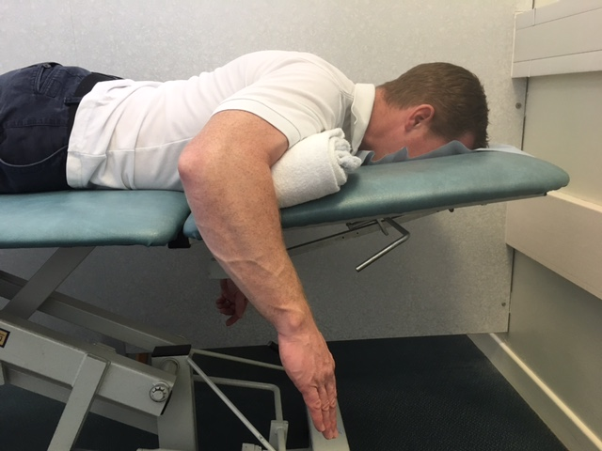
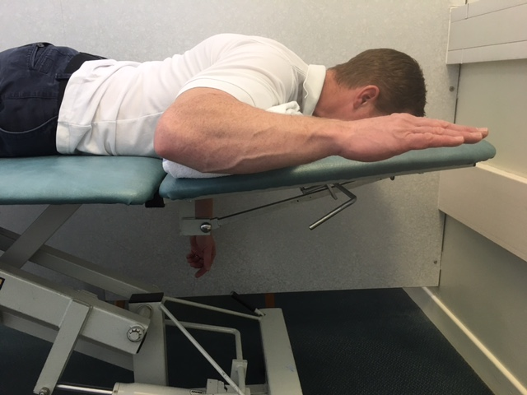
Lying face down with towel under forehead. Place a rolled towel under upper arm. Position your forearm off the bed with your elbow at right angle.
[Type a quote from the document or the summary of an interesting point. You can position the text box anywhere in the document. Use the Drawing Tools tab to change the formatting of the pull quote text box.]
[Type a quote from the document or the summary of an interesting point. You can position the text box anywhere in the document. Use the Drawing Tools tab to change the formatting of the pull quote text box.]
[Type a quote from the document or the summary of an interesting point. You can position the text box anywhere in the document. Use the Drawing Tools tab to change the formatting of the pull quote text box.]
[Type a quote from the document or the summary of an interesting point. You can position the text box anywhere in the document. Use the Drawing Tools tab to change the formatting of the pull quote text box.]

Sitting exercise to do

Supine LR exercise to do
2.

Lift your hand up towards the ceiling. Pivoting from the elbow, keeping wrist in neutral.
Repeat ______ times

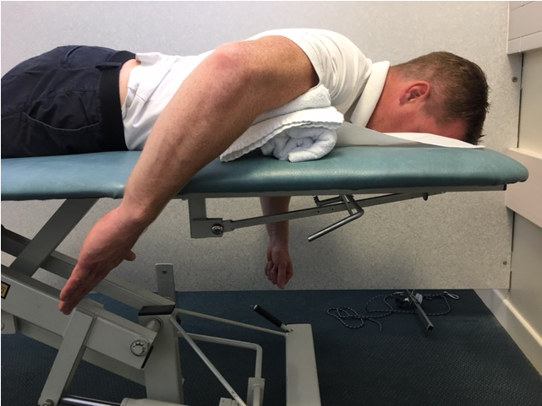
Lying face down with towel under forehead. Place a rolled towel under your upper arm. Position your forearm off the bed with your elbow at right angle.
[Type a quote from the document or the summary of an interesting point. You can position the text box anywhere in the document. Use the Drawing Tools tab to change the formatting of the pull quote text box.]
3.

Lift your hand back taking palm towards the ceiling. Pivoting from the elbow, keeping wrist in neutral.

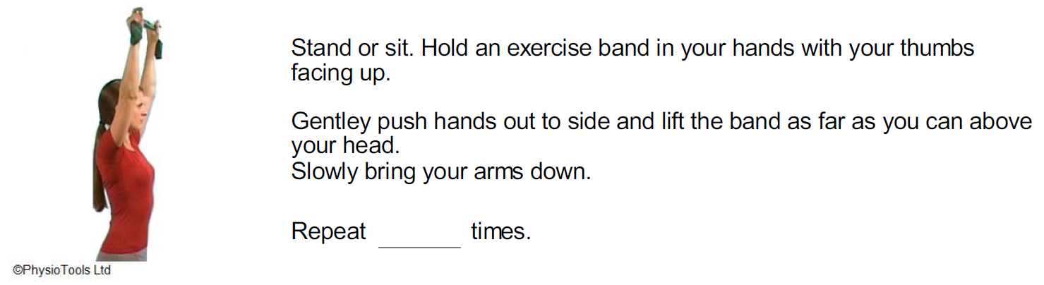
Repeat ______ times
Stand or sit. Hold an exercise band in your hands with your thumbs facing up.

Gently push hands out to side and lift the band as far as you can above your head.

Slowly bring your arms down maintaining tension as you lower the arm

Repeat _______ times
[Type a quote from the document or the summary of an interesting point. You can position the text box anywhere in the document. Use the Drawing Tools tab to change the formatting of the pull quote text box.]
4.
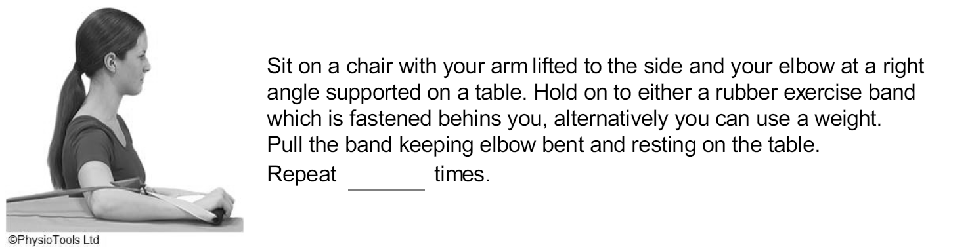
Sit on a chair with your arm lifted to the side and your elbow at a right angle supported on a table.

Hold on to a rubber exercise band which is fastened behind you, alternatively you can use a light wait. Pull the band forwards keeping elbow bent and resting on table

Repeat _______ times
5.
[Type a quote from the document or the summary of an interesting point. You can position the text box anywhere in the document. Use the Drawing Tools tab to change the formatting of the pull quote text box.]

6.
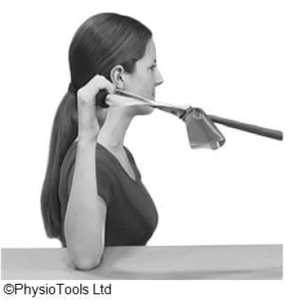
[Type a quote from the document or the summary of an interesting point. You can position the text box anywhere in the document. Use the Drawing Tools tab to change the formatting of the pull quote text box.]
Sit on a chair with your arm lifted to the side and your elbow at a right angle supported on a table.

Hold on to a rubber exercise band which is fastened in front of you, alternatively you can use a light weight. Pull the band backwards keeping elbow bent and resting on table

Repeat _______ times
6.

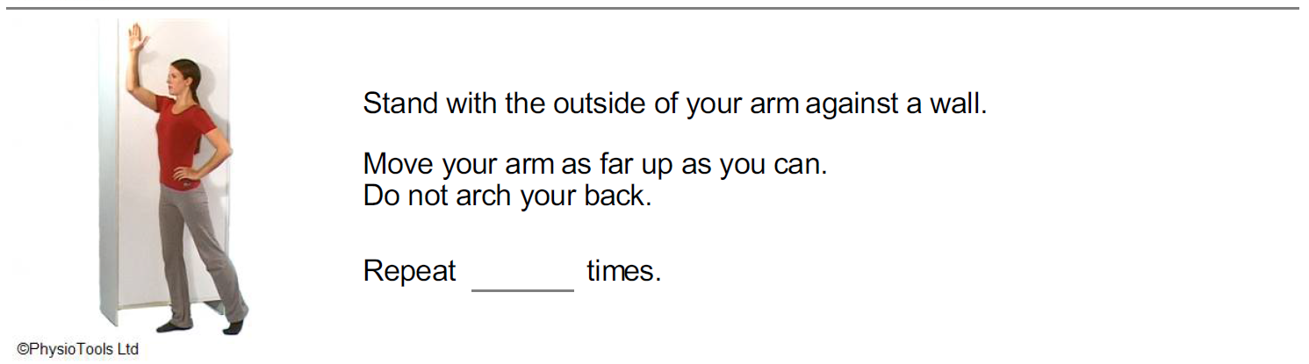
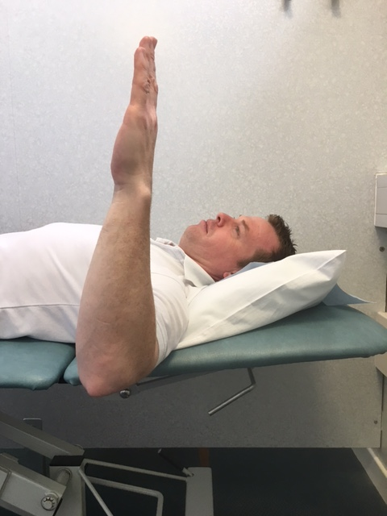
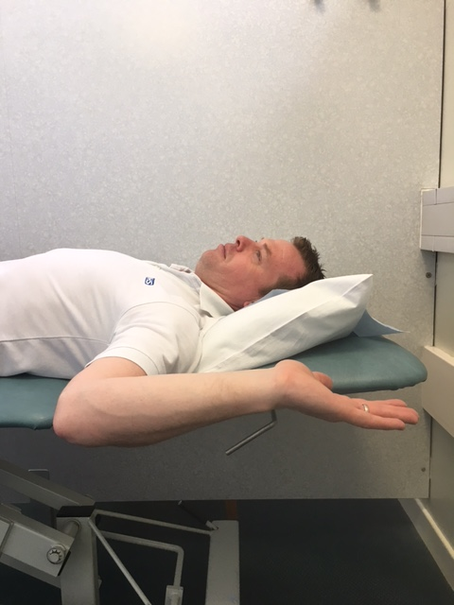
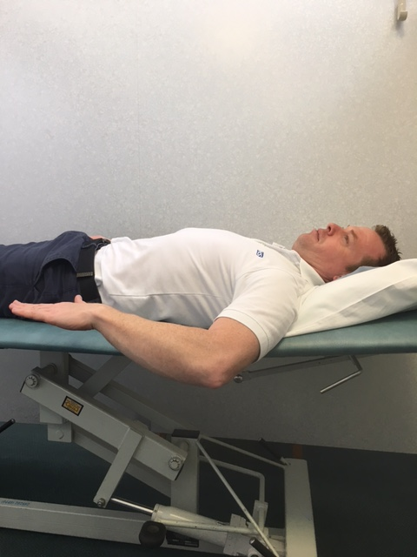

Lying on your back, place a rolled towel under your upper arm if required. Position your forearm off the bed with your elbow at right angle.
[Type a quote from the document or the summary of an interesting point. You can position the text box anywhere in the document. Use the Drawing Tools tab to change the formatting of the pull quote text box.]
[Type a quote from the document or the summary of an interesting point. You can position the text box anywhere in the document. Use the Drawing Tools tab to change the formatting of the pull quote text box.]
[Type a quote from the document or the summary of an interesting point. You can position the text box anywhere in the document. Use the Drawing Tools tab to change the formatting of the pull quote text box.]
[Type a quote from the document or the summary of an interesting point. You can position the text box anywhere in the document. Use the Drawing Tools tab to change the formatting of the pull quote text box.]

Sitting exercise to do
7.
[Type a quote from the document or the summary of an interesting point. You can position the text box anywhere in the document. Use the Drawing Tools tab to change the formatting of the pull quote text box.]
6.
7.
[Type a quote from the document or the summary of an interesting point. You can position the text box anywhere in the document. Use the Drawing Tools tab to change the formatting of the pull quote text box.]
Lower your hand back towards the floor. Pivoting from the elbow, keeping wrist in neutral.
[Type a quote from the document or the summary of an interesting point. You can position the text box anywhere in the document. Use the Drawing Tools tab to change the formatting of the pull quote text box.]

Repeat ______ times

Lying on your back, place a rolled towel under your upper arm if required. Position your forearm off the bed with your elbow at right angle.
8.
8.
[Type a quote from the document or the summary of an interesting point. You can position the text box anywhere in the document. Use the Drawing Tools tab to change the formatting of the pull quote text box.]
[Type a quote from the document or the summary of an interesting point. You can position the text box anywhere in the document. Use the Drawing Tools tab to change the formatting of the pull quote text box.]
Lower your hand forwards towards the floor. Pivoting from the elbow, keeping wrist in neutral.

Repeat ______ times

Stand with the outside of your arm against the a wall.

Move your arm as far up as you can.
Do not arch your back.

Repeat _______ times
9.

[Type a quote from the document or the summary of an interesting point. You can position the text box anywhere in the document. Use the Drawing Tools tab to change the formatting of the pull quote text box.]

Contact details
[Type a quote from the document or the summary of an interesting point. You can position the text box anywhere in the document. Use the Drawing Tools tab to change the formatting of the pull quote text box.]
9
[Type a quote from the document or the summary of an interesting point. You can position the text box anywhere in the document. Use the Drawing Tools tab to change the formatting of the pull quote text box.]
9.
The Health Information Centre
Poole Hospital NHS Foundation Trust
Longfleet Road, Poole, Dorset
BH15 2JB
Telephone: 01202 442121
Author: Andy Hayward

