**Please remember to exercise pain free unless otherwise informed by physiotherapist**

4.

3.

1.

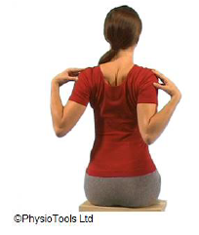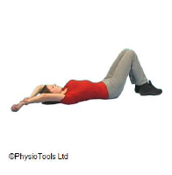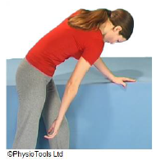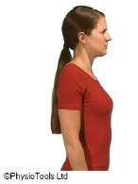

Sit or stand.

Place your fingers on your shoulders or breast bone.

Roll your shoulders back and lift your breast bone towards the ceiling.

Repeat times.

Lying on your back with elbows straight.

Use one arm to lift the other arm up keeping it as close to the ear as possible.

Repeat ____ times.

Stand leaning on a table with one hand.

Let your other arm hang relaxed straight down. Swing your arm forwards and backwards.

Repeat ____ times.

2.

Stand or sit.

1. Move your shoulder blades gently back and down

(small movement).

2. Roll your shoulders in both directions.

Repeat ____ times.

**Please remember to exercise pain free unless otherwise informed by physiotherapist**

7.

6.

5.

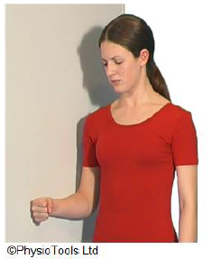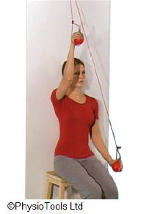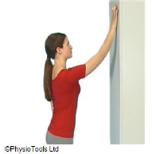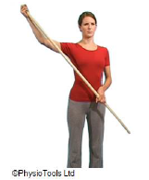

Stand sideways against a wall with your upper arm under your shoulder and elbow either straight or at a right angle.

Push the elbow (if bent) or forearm (if straight) to the side against the wall

Repeat _____ times

Stand facing a wall.

'Walk' your fingers up the wall as high as possible. Reverse down in the same way.

Repeat ____ times.

Pull a rope through a ring located high above your head.

Sit with your back against a wall. Hold onto both ends of the rope.

Lift your affected arm, assist by pulling down with the other

hand.

Repeat ____ times.

Stand and grip one end of a stick with the arm to be exercised, with the thumb facing towards the ceiling.

Lift your arm the side, assist by pushing with the other hand.

Repeat ____ times.

8.

8.