**Please remember to exercise pain free unless otherwise informed by physiotherapist**

4.

3.

1.

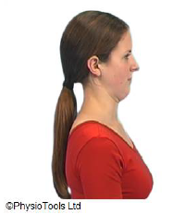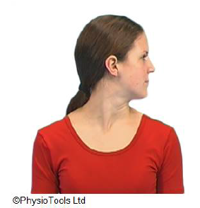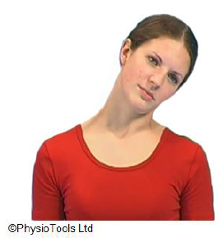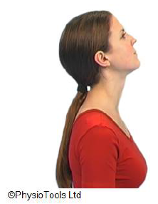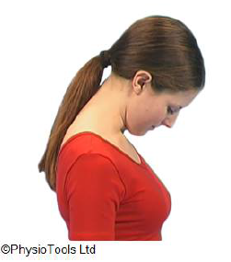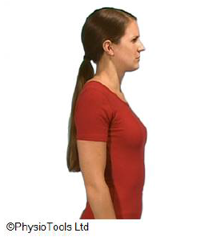

Sitting straight-backed.

Pull your chin in, keeping your neck and back straight (not tipping your head forwards).

Hold at the end position and feel the stretch in your

neck.

Repeat ____ times.

Sitting or standing

a. Tilt your head toward one shoulder until you feel the stretch on the opposite side.

b. Turn your head to one side until you feel a stretch.

Hold approx. 30 secs. Repeat to other side.

Repeat _____ times.

b.

a.

Sitting or standing

Bend your head backwards and forwards as far as is comfortable.

Repeat ____ times.

2.

Stand or sit.

Move your shoulder blades gently back and down (small movement).

Hold 5 seconds.

Repeat ____ times.

**Please remember to exercise pain free unless otherwise informed by physiotherapist**

7.

6.

5.

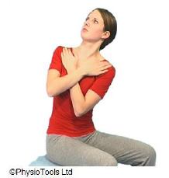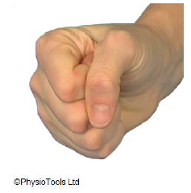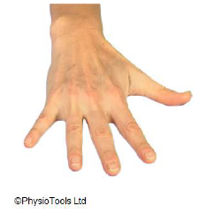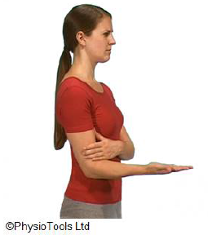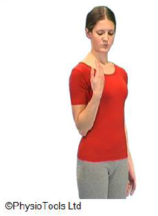

8.

Sit on a chair and support your arms on your chest.

Rotate the upper trunk.

Keep your upper trunk straight and let your eyes follow the movement.

Repeat ____ times.

Palm on a table.

a. Spread fingers and bring them together.

b. Make a fist.

Repeat _____ times.

a.

b.

Stand with your elbow bent and palm turned down.

Turn your palm up and down rotating your forearm.

Repeat ___ times.

Standing

Bend your elbow and then straighten your elbow.

Repeat ____ times.