Visual fixation on a still target

Hold a business card in your hand at arm’s length so that you can see the larger words clearly.
You could tape the card on a wall in front of you.
Keep your eyes focused on the larger words on the card.
- You can move your head from side to side, keeping the words in focus at all times.
- Try to do this for 1-2 minutes without stopping.
- You should stop only if the larger words becomes unclear or you get VERY dizzy. If the word becomes hard to read, try moving our head a little slower.
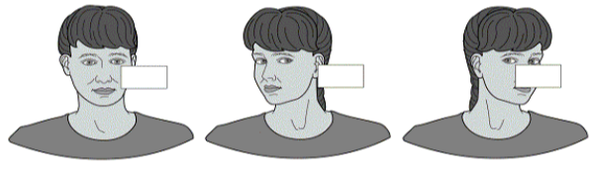

Active eye movements between two targets

Hold or place 2 targets (ie, cards with one word written on each card) at arm's length in front of you about 8-10 inches apart. Look directly at the first target being sure that your head is also lined up with the target. Next, look at the second target with your eyes only and then turn your head to line up with the target. Be sure to keep the target in focus as you turn your head. Repeat in the opposite direction.
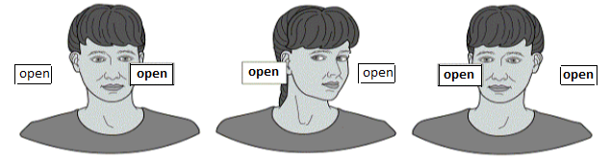

That is, start by looking at the second target with your eyes only and then turn your head so it is aligned with the same target. Then look at the first target with your eyes and then turn your head to the first target. Continue moving your eyes to one target, then following with your head for 5 minutes, resting if necessary. Vary the speed of the head movement but always keep the targets in focus.

Imaginary Targets
Look at a target (card with one word written on it) held directly in front of you at arm's distance. Close your eyes and turn your head slightly to one side, imagining that you are still looking directly at the target. Next, open your eyes and check to see if you have been able to keep your eyes on the target. Repeat in the opposite direction.
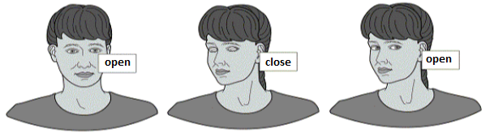
Be as accurate as possible, checking each time to see how close you get to keeping your eyes on the target. Continue moving your head side to side, varying the speed of head movement. Practice for up to 5minutes, resting if necessary.

How to vary and progress the exercise difficulty

- Do the exercises in sitting
- Do the exercises in standing with your feet ............cm apart
- Practice this exercise at different speeds of head movement (slow, medium, fast)
- Repeat the exercise moving your head up and down for 1-2 minutes
- Repeat the exercises using a large pattern in the background such as a checkerboard, wallpaper or your television.
- First, move your head from side to side for 1-2 minutes. Rest briefly. Then move your head vertically for 1-2 minutes.
- First try with the business card close to you, then with the business card further across the room.

References
http://www.mccc.edu/~behrensb/documents/VestibularRehabilitationTherapy.pdf
[online 11/06/2014]
http://visionhelp.files.wordpress.com/2011/12/gaze-stabilization-exercises.gif [online 11/06/2014]

Author. Ian Kennedy, Jackie Kidd, Elaine Dechow

The Health Information Centre, Poole Hospital NHS Foundation Trust, Longfleet Road, Poole
Dorset, BH15 2JB Therapy services 01202 442121

