Semont Manoeuvre

This is an exercise used to treat BPPV (Benign Paroximal-Positional Vertigo).

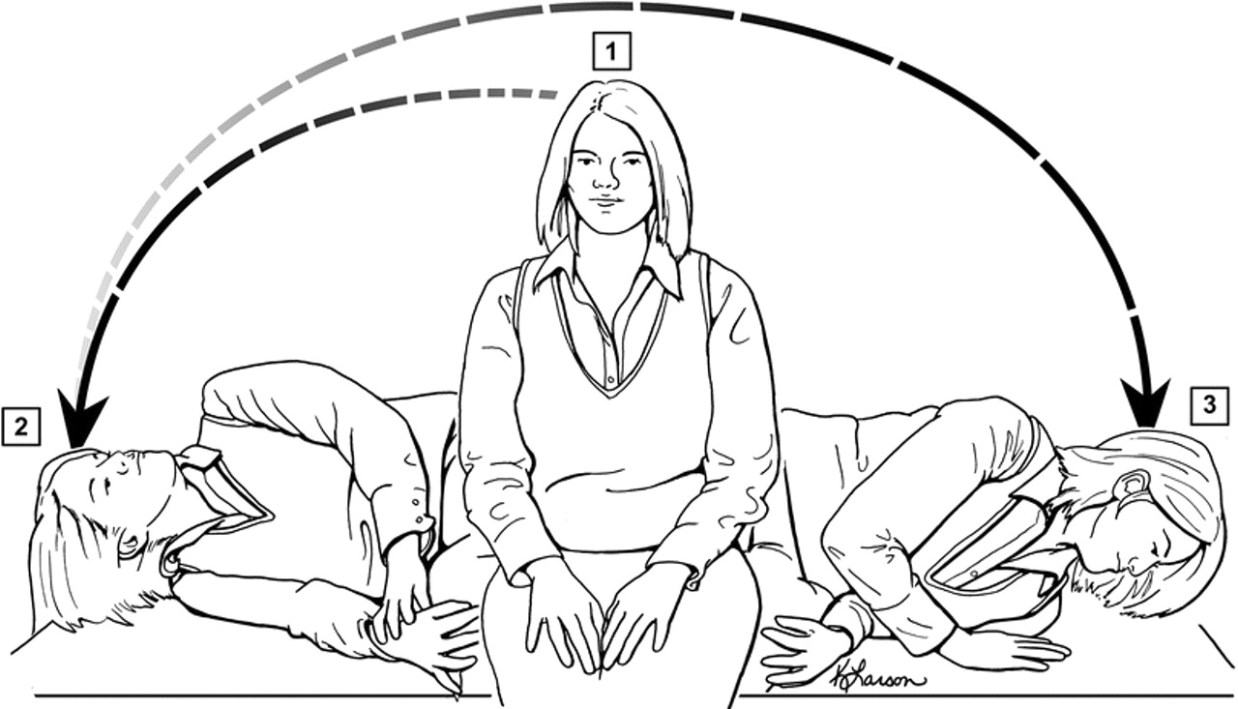

- Sit straight and turn your head at an angle of 45° horizontally towards the unaffected ear.
- Tilt you head up at an angle of 100° so that you are lying on the side of the affected ear with your head hanging back slightly and facing upwards. Remain in this position for around 3 - 5 minutes, this allows the debris (inner ear crystals) to move to the apex of the ear canal.
- Keeping your head in the same position, lie on the side of the unaffected ear with your nose pointed to the ground. Remain in this position for 3 - 5 minutes, allowing the debris to move towards the exit of the ear canal.
- Finally move back to your initial sitting position and relax.

References
http://www.neurology.org/content/70/22/2067/F3.large.jpg [online 11/06/2014]

Contact details
Outpatients Physiotherapy

Telephone number 01202 442121

For further general health-related information, please ask the relevant department for an Information Prescription or contact:

The Health Information Centre
Poole Hospital NHS Foundation Trust
Longfleet Road
Poole

Dorset
BH15 2JB
Telephone: 01202 448003

www.poole.nhs.uk

Author: Ian Kennedy Elaine Dechow Jackie Kidd Andy Hayward
Date: 11/06/2014
Review date: Ongoing
Version number:

We can supply this information in other formats, in larger print, on audiotape, or have it translated for you. Please call the Patient Advice and Liaison Service (PALS) on 01202 448499, text 07758 272495 or email pals@poole.nhs.uk for advice.

If you wish to make any comments or to ask about any research evidence used to write this leaflet, please contact the Patient Information Team confidentially: phone 01202 448003, write to the Health Information Centre (address above), or email patient.information@poole.nhs.uk.

