Mobilising and Strengthening Exercises for the Lumbar Spine

About Back Pain
Back Pain is very common and causes a great deal of discomfort but fortunately serious or permanent damage is rare.
Exercise gets your back moving again by stretching tight muscles and joints and stops the spine from seizing up. Staying active will help you get better faster and prevent more back trouble.

Exercises
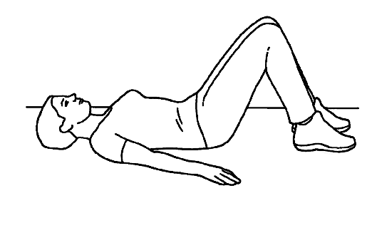
1. Pelvic Tilt

- Lie on your back with your knees bent and arms by your sides. Tighten your stomach muscles and buttocks and flatten your lower back into the floor. Hold 5 seconds.

Repeat _____ times

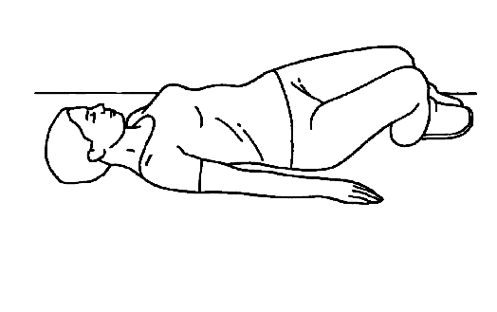
2. Lumbar Rotation

- Lie on your back with your knees bent and arms by your sides. Slowly rock your knees from side to side in a small, pain-free range of motion. Allow your lower back to rotate slightly.

Repeat _____ times
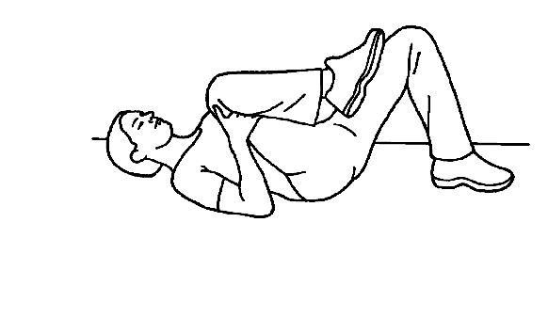
3. Single Knee to Chest Stretch

- Lie on your back with your knees bent. Draw one knee in to your chest until a comfortable stretch is felt in the lower back and buttocks. Repeat with opposite knee. Hold 20 seconds.

Repeat _____ times
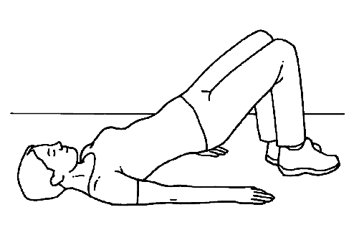
4. Bridging

- Lying on your back with knees bent and feet on the floor. Lift your pelvis gradually off the floor keeping your stomach muscles tight. Hold the position and lower slowly down returning to the starting position.

Repeat _____ times

“copyright Physiotools Ltd. All rights reserved. Use with permission of Physiotools Ltd.”

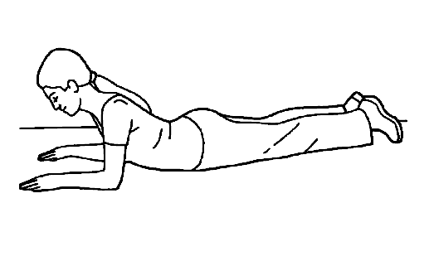
5. Prone on elbows

- Lie on your tummy with your elbows in line with your shoulders. Raise up onto your elbows slowly whilst keeping your hips on the floor.

Repeat _____ times

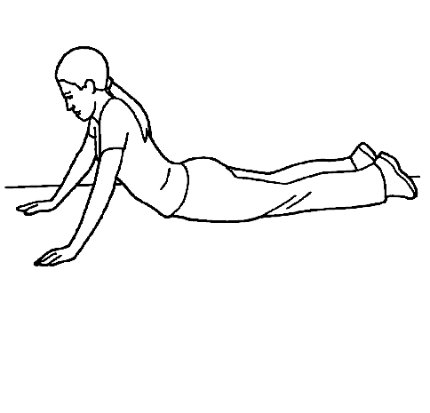
6. Press-Up

- Lie on your tummy with your hands level with your shoulders. Push upper body upwards into position shown, keeping hips in contact with the floor. Keep your lower back and buttocks relaxed.

Repeat _____times

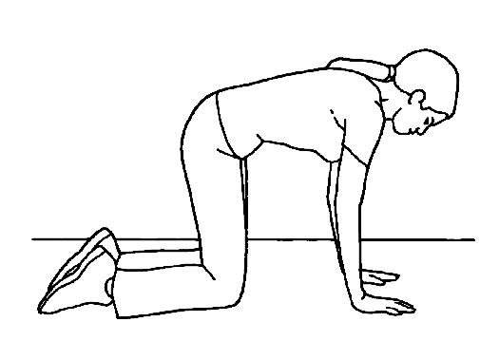
7. Angry Cat Stretch

- In a crawling position, hips above knees and shoulders above wrists. Tuck your chin, tighten your stomach and arch your back up towards the ceiling. Hold for _____ seconds then gently return to neutral starting position.

Repeat _____ times

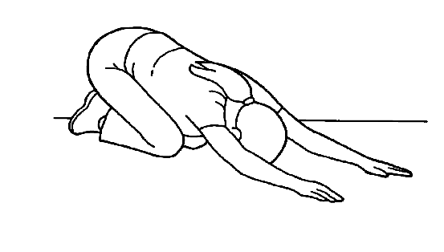
8. Mid Back Stretch

- In a crawling position. Sit back on your heels while at the same time, slide your arms forwards along the floor. Push your chest towards the floor. Ensure your bottom stays down on your heels. Hold for _____ seconds.

Repeat _____ times

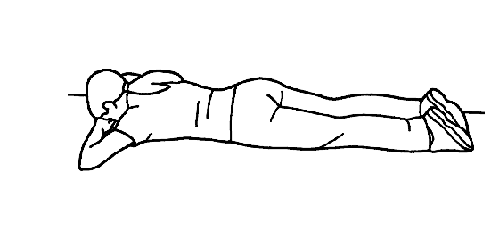
9. Transverse Abdominals

- Lying on your tummy. Tighten your abdominals by drawing your navel towards your spine. (As guided by your therapist).

Repeat _____ times

“copyright Physiotools Ltd. All rights reserved. Use with permission of Physiotools Ltd.”

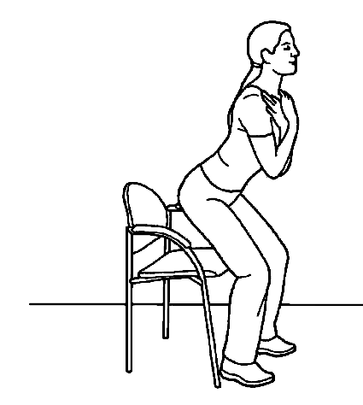
10. Sitting to Standing

- Sitting in chair with your feet hip width apart. Stand up and then sit down slowly with control. (This can be made easier or more difficult by changing the chair height).

Repeat _____ times

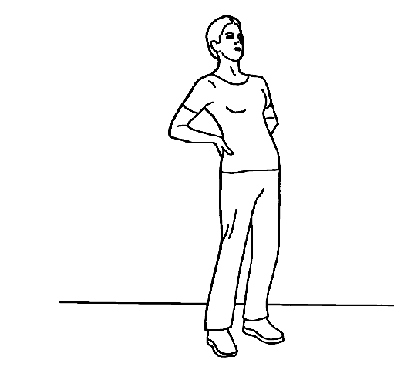
11. Standing Backward Bend

- Stand straight with feet hip width apart. Support your back with your hands while arching backwards. Keep your knees straight during the exercise.

Repeat _____ times

12. Alternate arm and Leg Lift
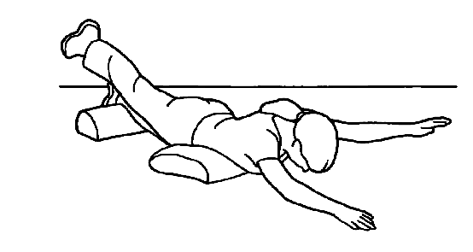
- Lying face down with your arms above your head. (You can place a pillow under your stomach and one under your ankles for comfort).

Lift opposite arm and leg approx. 20cm off the floor. Keep your knee locked throughout. Lower your arm and leg with control back to the starting position.

Repeat _____ times on each side

“copyright Physiotools Ltd. All rights reserved. Use with permission of Physiotools Ltd.”
Contact details

Physiotherapy Out-Patient Team, Therapy Services Department
Telephone: 01202 442121

For further general health-related information, please ask the relevant department for an Information Prescription or contact:

The Health Information Centre
Poole Hospital NHS Foundation Trust
Longfleet Road
Poole
Dorset

Information Standard logo to be inserted here on final copy of leaflet. Your leaflet cannot be given to patients until this logo has been inserted. The logo can only be applied by the Patient Information Team.

BH15 2JB
Telephone: 01202 448003

www.poole.nhs.uk

Author: Jackie Kidd
Date: November 2013
Review date: Under Review
Version number: 1
Ward sister/head of department: Hilary Hall

We can supply this information in other formats, in larger print, on audiotape, or have it translated for you. Please call the Patient Advice and Liaison Service (PALS) on 01202 448499, text 07758 272495 or email pals@poole.nhs.uk for further advice.

If you wish to make any comments on this leaflet, please contact the Patient Information Team confidentially: by phone on 01202 448003, by post to the Health Information Centre (address above), or email patient.information@poole.nhs.uk.

