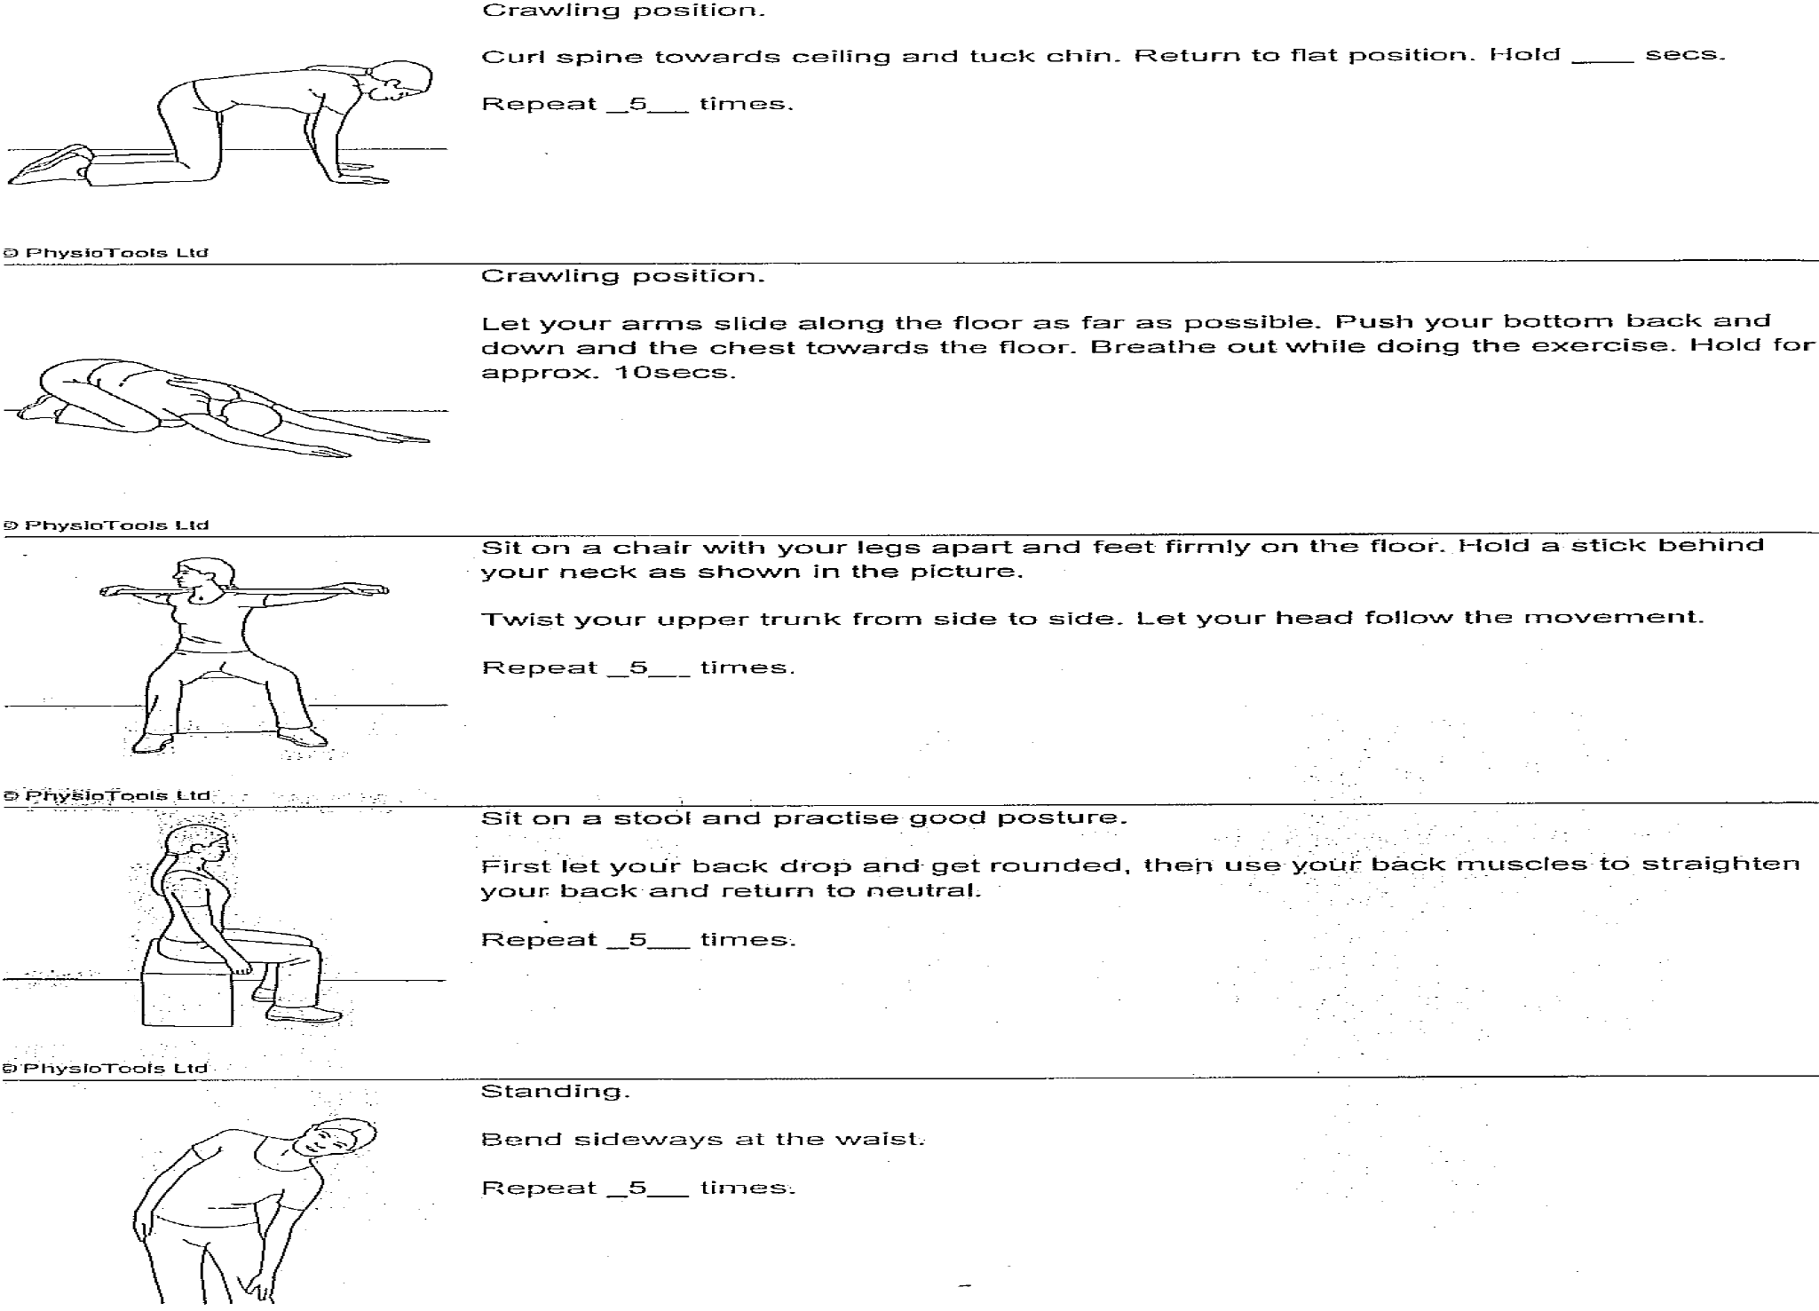

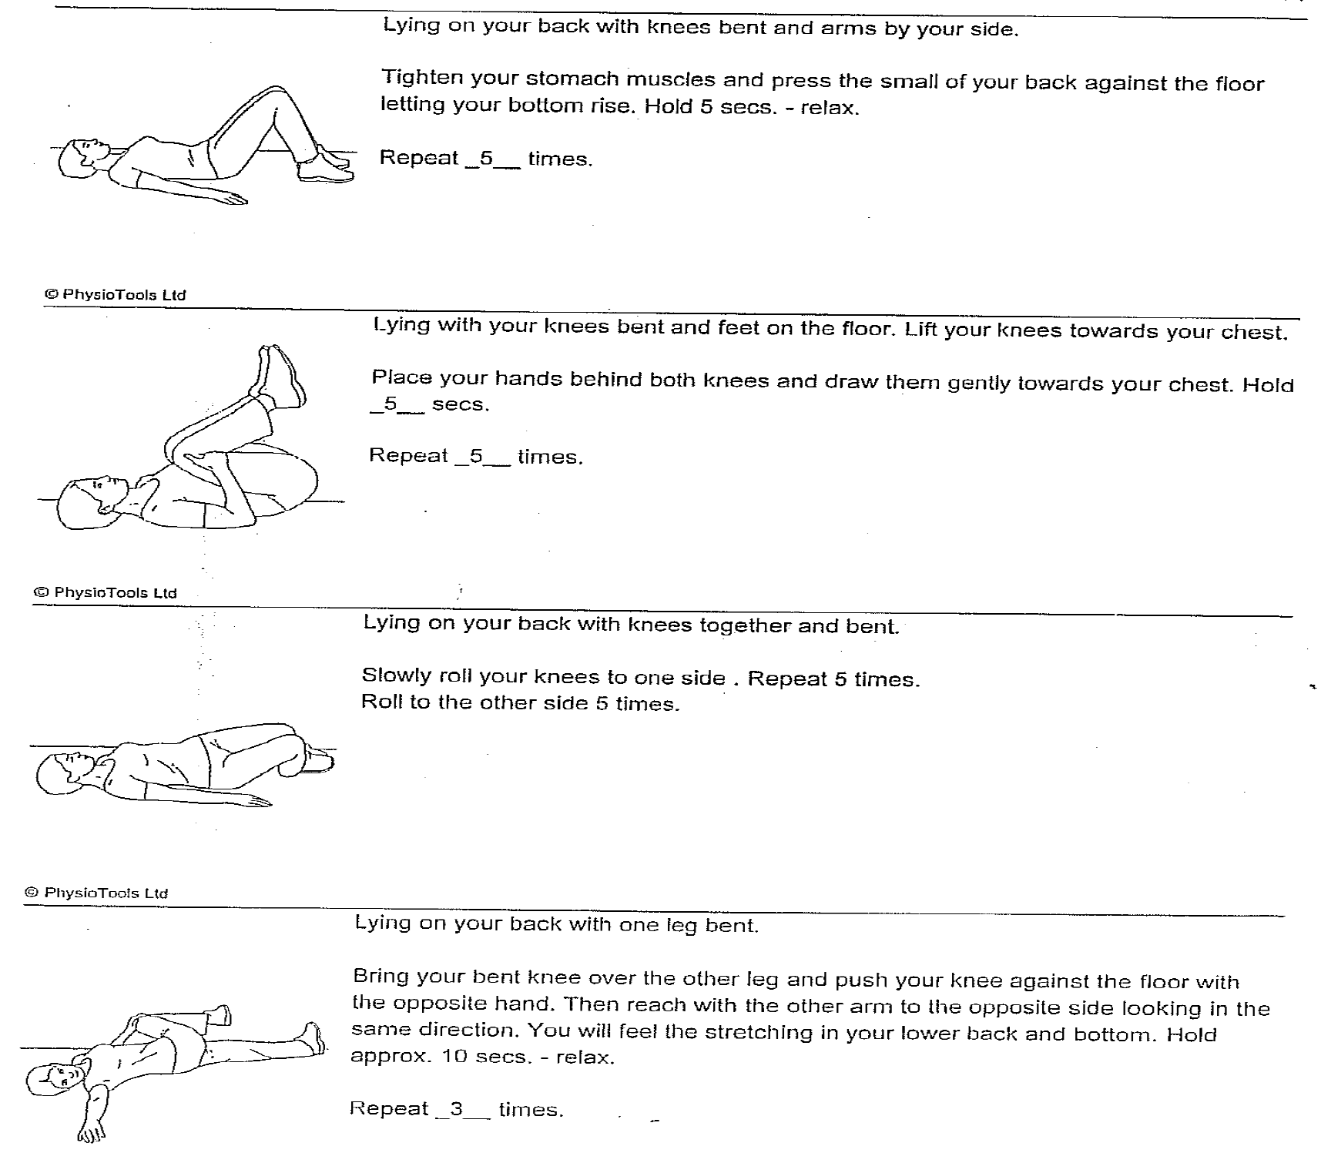
Contact details www.poole.nhs.uk
The Health Information Centre
Poole Hospital NHS Foundation Trust
Longfleet Road
Poole
Dorset
BH15 2JB
Telephone: 01202 442121 Author: Ian Kennedy, Jackie Kidd Date: 31-Jul-26

