**What is it?**

[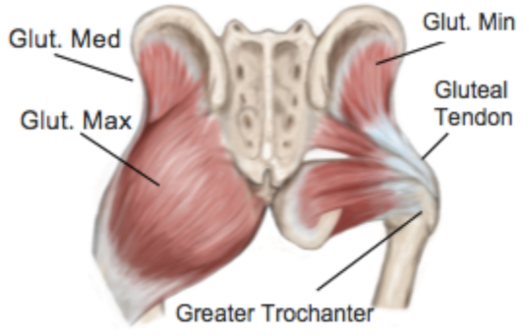](https://www.google.com/url?sa=i&rct=j&q=&esrc=s&source=images&cd=&ved=&url=https://telmagrant.com/gluteal-tendinopathy/&psig=AOvVaw1iZeO5EGOTN0fFqkG9Y_Tt&ust=1564745597148034)Lateral hip pain or Greater Trochanteric Pain Syndrome (GTPS) occurs when the tendons and other structures around the hip become painful and inflamed. The tendons all attach onto the greater trochanter, as shown in the image. This is generally the area that you will experience pain, but the pain can also radiate towards the knee, groin or buttock area.

<https://telmagrant.com/gluteal-tendinopathy/>

**Why does it happen?**

The most common cause of these symptoms is abnormal loading of the tendons around the hip. A sudden increase in load or activity can lead to lateral hip pain, particularly if the person was not doing much activity before. Alternatively, lateral hip pain can develop gradually after a direct fall onto the area, due to the load being put through the tendon after it has been weakened from the injury.

**Diagnosis**

Physical examination by your GP or Physiotherapist is usually all that is needed for diagnosis.

**What can I do?**  
Whilst you do not want to aggravate the tendons, complete rest is also not helpful.   
Try to keep active, try using heat or ice over the painful area and take pain relief if necessary/as advised.

Evidence supports the use of specific exercise programmes to address muscle imbalance, guided by a physiotherapist.

In some cases, a corticosteroid injection may provide pain relief. After an injection you will be advised to start engaging in an exercise program to address the issue that caused the pain in the first place.

Below are some suggested exercises that you can try whilst waiting for your physiotherapy assessment. These should not aggravate your symptoms but you may feel an ache afterwards. It is advised to stop any of the exercises if they aggravate your symptoms or any other problems you may have.

1. Static Abduction

* Lay on your back with your knees slightly wider than hip width, a pillow under the knees and a belt scarf around your lower thighs.
* Gently move your knees apart to take up the slack in the belt/scarf, hold for 5 seconds, relax and repeat.
* This should be a very small amount of movement and you should feel a gentle tension at the side of your hips/buttocks.

1. 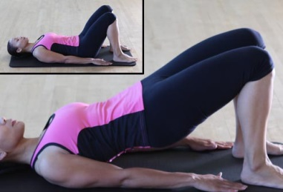Bridging

* Lay on your back with your knees bent and knees hip width apart.
* Draw in your lower abdomen, contract your buttock muscles and lift your bottom off the bed to a comfortable height.



1. Double leg squat

* Stand with legs hip width apart and weight equally through both legs.
* Bend at the knees and hips as if you are going to sit down, ensuring your back is straight, knees facing forwards and weight is in your heels.

The aim of this leaflet is to give you some understanding of the problems you may have with your hip. It is not a substitute for professional advice and should be used along with information given by your GP or Physiotherapist. If symptoms continue to persist despite allowing time with conservative measures then please discuss this further with your GP.

References:   
1. <https://telmagrant.com/gluteal-tendinopathy/> [Online picture 20-8-19]   
2. National Institute for Health and Care Excellence (NICE), 2016. Greater Trochanteric Pain Syndrome (trochanteric bursitis) [online 9-2-17] Available from: <https://cks.nice.org.uk/greater-trochanteric-pain-syndrome-trochanteric-bursitis> [Online 9-2- 17]   
3. <https://patient.info/bones-joints-muscles/hip-problems/greater-trochanteric-pain-syndrome-trochanteric-bursitis> [Online 9-2-17]  
4. <https://www.bmj.com/content/361/bmj.k1662> Mellor et al. 2018 ‘Education plus exercise versus corticosteroid injection use versus a wait and see approach on global outcome and pain from gluteal tendinopathy: prospective, single blinded, randomised clinical trial’ 361:k1662 **5.** <https://www.webmd.com/fitness-exercise/ss/slideshow-15-pilates-moves> [Online picture 20-8-19]  
  
Contact details:   
Therapy Services Department 01202 442121  
For further general health-related information, please ask the relevant department for an Information Prescription or contact:   
The Health Information Centre   
Poole Hospital NHS Foundation Trust   
Longfleet Road   
Poole   
Dorset   
BH15 2JB

Author: Therapy Services Department, Elli Higgins  
Date: August 2019  
Review Date:   
Version 2