Walking on a the flat.
We recommend you progress your walking gradually to avoid unnecessary flare ups of your symptoms. Remember there needs to be muscular discomfort from the effort to ensure the strength continues to improve.
Try hill walking
Try walking on uneven ground i.e. turf

Time……………. Resistance……………..

Climbing up and down the stairs.
We recommend you progress your climbing gradually to avoid unnecessary flare ups of your symptoms. Remember there needs to be muscular discomfort from the effort to ensure the strength continues to improve.
Try increasing your pace

Repeat …………….

Balance
We recommend you adopt the 'heel to toe' standing formation seen.
Try and balance for 20 seconds.

Repeat …………….

Balance
We recommend you adopt the one leg balance standing formation seen.
Try and balance for 20 seconds.

Repeat …………….

Marching on the spot.
In bad weather it is often not possible to get out of the house.
Try marching on the spot.

Continue for ……………. mins

Sit to stand.
Sit with your hands on your shoulders.
Stand up by tightening your buttock muscles.
Slowly sit back down using the thigh muscles.
Repeat ……………. times

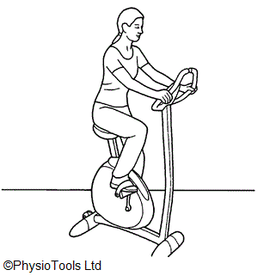  References |  | Cycling on a static bike.  We recommend you progress your cycling gradually to avoid unnecessary flare ups of your symptoms. Remember there needs to be muscular discomfort from the effort to ensure the strength continues to improve.  Time……………. Resistance……………..
- Fransen M, McConnell S, Harmer AR, Van der Esch M, Simic M, Bennell KL. Exercise for osteoarthritis of the knee.
Cochrane Database of Systematic Reviews 2015, Issue 1. Art. No.: CD004376. DOI: 10.1002/14651858.CD004376.pub3.
Contact details www.poole.nhs.uk
Poole Hospital NHS Foundation Trust
Longfleet Road
Poole Dorset
BH15 2BJ
Author: Ian Kennedy

