Current research suggests that water-based therapy is effective in the management of knee osteoarthritis and lower limb deconditioning.

The buoyancy of the water reduces the impact through your joints, deceasing pain levels and allowing a higher intensity of activity and exercise. This means that water-based treatment can help to limit stiffness, improve your movement and strengthen your muscles. As well as this, the increased pressure on your body in the water can help to reduce swelling and improve circulation. This can all lead to increased confidence and function, which is why water-based therapy has been found to be as beneficial as exercises on land.

Attached is an exercise sheet including the exercises which have been found to be most beneficial for people with knee osteoarthritis. Completing these exercises for 45 minutes at least once a week in your local swimming pool may help to reduce your symptoms.

Marching on the spot

Stand holding on to the wall/rail
Lift one knee towards the surface
Repeat on the other leg.

Continue for ………….. minutes.

Heel flicks

Place an armband around your ankle (Can do the exercise without an armband).
Stand holding on to the wall/rail
Bend your knee towards your bottom
Repeat 10 times x3 sets.

Side kicks

Stand holding on to the wall/rail
Keeping your knee straight lift your leg out to the side away from your body
Return to the middle and repeat
Repeat 10 times x3 sets.

Lunges

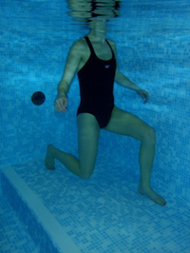
Step one leg forwards with the foot flat on the floor
Bend your front knee and lower your back knee towards the floor as shown in the picture
Stand back up and repeat on other leg
Keep your back straight
Repeat 10 times x3 sets.

Step ups

Place your bad leg on a step in the pool
Keeping your back straight, step up pushing through your heel
Then step back down
Keep your back straight
Repeat stepping up and down
Repeat 10 times x3 sets.
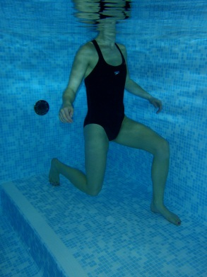
Lunges
- Step one leg forwards with the foot flat on the floor
- Bend your front knee and lower your back knee towards the floor as shown in the picture
- Stand back up and repeat on other leg
- Keep your back straight
- Repeat 10 times x3 sets.
Step downs

Standing at the top of a step
Slowly lower your good leg to the floor by bending your bad leg
Keep your back straight
Return to starting position keeping your bad leg on the step
Repeat 10 times x3 sets

Squats

Stand with your back against the wall feet hip width apart
Bend your knees keeping your back against the wall
Stand back up
Repeat 10 times x3 sets.

Cycling in the corner

In the corner of the pool hold on to the sides
Let your legs slowly lift off the floor keeping your bottom down
Cycle your legs as if you are pedalling a bike
Keep your back straight and your bottom in the corner
Continue for 2 minutes

Warm up and cool down

30
3
3
30

References
- Silva LE, Valim V, Pessanha APC, Oliveira LM, Myamoto S, Jones A, Natour J (2008) Hydrotherapy versus conventional land-based exercise for the management of patients With Osteoarthritis of the knee: A randomized clinical trial. PHYS THER. 2008; 88:12-21
- Rewald, S. et al. 2015. Aquatic circuit training including aqua-cycling in patients with knee osteoarthritis: a feasibility study. The Journal of Rehabilitation Medicine, 47 pp. 376-381.
- Waller, B. et al. 2014. Effect of therapeutic aquatic exercise on symptoms and function associated with lower limb osteoarthritis: systematic review with meta-analysis. The Journal of the American Physical Therapy Association, 94 pp. 1383-1395.
Contact details
The Health Information Centre
Poole Hospital NHS Foundation Trust
Longfleet Road
Poole Dorset BH15 2JB
Telephone: 01202 442121
www.poole.nhs.uk Author: Hydrotherapy team, Ian Kennedy Date: 05/11/2015

