A catching or pinching pain in the groin during activity, perhaps accompanied by low back, buttock and lateral hip pain are usually the main symptoms of a hip impingement. Injury or deficit of the buttock muscles can affect hip control and cause an impingement. There are three different types. The first involves an issue with upper surface of the femoral head (ball), known as a Cam issue. The second is due to an issue with the acetabular cup (socket) and is known as a 'Pincer' issue. The third is a combination of the two.¹⁻⁴ Physiotherapy can help address these problems.
Nerves: Femoral nerve L2-4, Obturator L2-4, Gluteal nerve L4-S1.

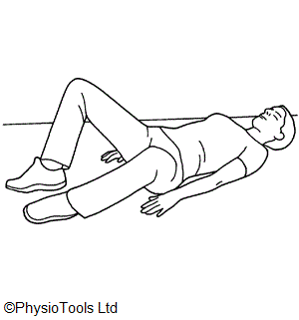
Hip twist

Lying with your knees bent and feet on the floor hip width apart.
Turn the soles of your feet to face each other and allow your knees to fall outwards. Work to the end of range. Keep your back flat on the floor during the exercise.
Repeat ………………times.

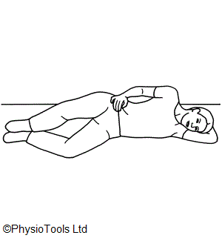
Add a resistive band

Clam

Lie on your side with your knees bent.
Tighten your buttocks. Lift your top knee as far as you can, without letting your pelvis rotate forward or back. Hold for a second. Keep your feet together and back straight during the exercise.
Repeat ………………times.

Add a resistive band

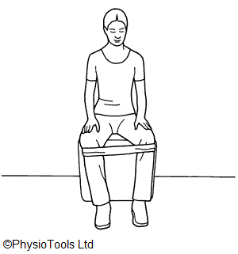
Seated hip abduction

Sit on a chair. Put a rubber exercise band around your knees.
Spread knees apart as far as you can. Slowly bring knees back together.
Repeat ………………times.
Side kicks
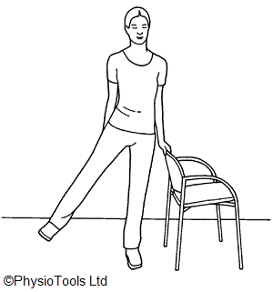

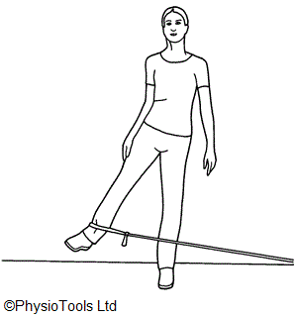
Stand straight holding on to a support. Lift your leg sideways and bring it back keeping your trunk straight throughout the exercise.

Repeat ………………times.
Add a resistive band

Back kicks
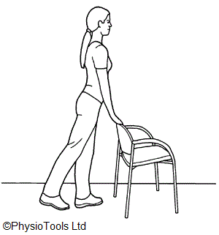
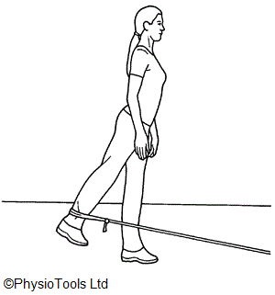
Stand straight holding on to a chair.
Bring your leg backwards keeping your knee straight. Do not lean forwards.
Repeat ………………times.
Add a resistive band

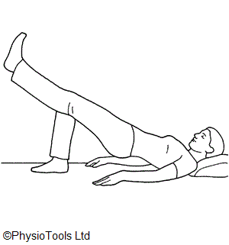
Bridging
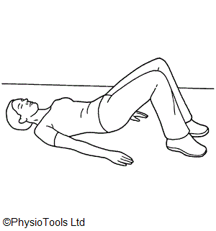
Lying on your back with knees bent.
Squeeze your buttocks together and lift your bottom off the floor. Return to starting position.

Repeat ………………times.

Add a gentle slow kick

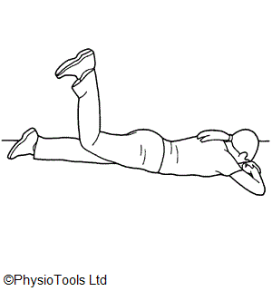
Prone glut kick ups

Lying face down.
Bend your knee to a right angle and lift your foot towards the ceiling. Squeeze the buttocks.

Repeat ………………times.

Hip rotator strengthening

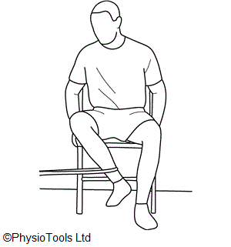
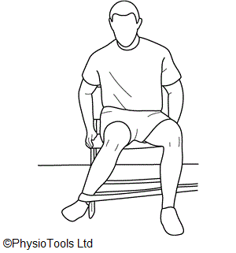
Sit with knees together, apply band.
1. Pull your foot outwards against the resistance, keep knees together. Return to starting position (left).
Repeat ………………times.
2. Pull your foot in towards the other and against the resistance of the band, keep knees together. Return to starting position (right).
Repeat ………………times.

Side lying circles

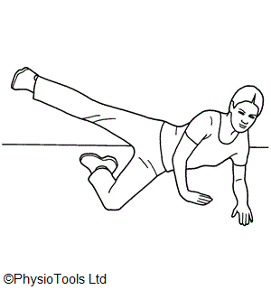
Sidelying flat on the bed or propped up on your elbow as shown. Keep the leg on the floor bent and upper leg straight as in the picture.
Lift upper leg behind you as far back as you can comfortably.
With heel leading make small circles behind you.
Repeat ………………times.

Lunge stretch

Stand straight with hands on hips, one knee bent in front, and the leg to be stretched is supported on a stool or chair by its shin and foot as shown. Avoid putting weight through the knee.
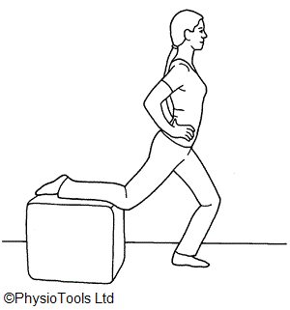
Bend your front leg, lunging forward from the waist, it’s important to keep your back upright, don’t let it arch. Feel the stretch in the front of the thigh on the supported leg.

Hold for ……………..seconds
Repeat ………………times.

The hip flexor and quads stretches - ‘towel stretch’

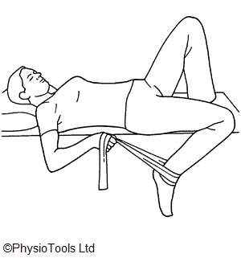
Lay on your back, keeping your pelvis tilted backwards and your lower back flat against the bed.
Hold onto your ankle with a towel. Gently draw your foot towards your buttock. Feel the stretch, don’t let your back arch.

Hold for ……………..seconds.
Repeat ………………times.

Hurdle stretch

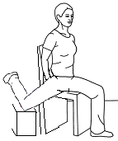

Sit on a chair or your sofa.

The leg whose hip needs the stretch can be lifted onto a cushioned stool beside you (or the sofa seat). Bring the leg as far to the side and behind you as you can, feel the deep stretch in the hip.

Hold for …………… seconds.
Repeat ………………times.

References
- Beck M, Kalhor M, Leunig M, Ganz R ( 2005). "Hip morphology influences the pattern of damage to the acetabular cartilage: femoroacetabular impingement as a cause of early osteoarthritis of the hip". J Bone Joint Surg Br July 2005;87 (7): 1012–8.
- http://anatomyresources.hsc.wvu.edu/nm_deficits/Superior_Gluteal.html [online 3/3/16]
- Thieme Atlas of Anatomy: General Anatomy and Musculoskeletal System. Thieme. 2006. ISBN 1-58890-419-9.
- http://www.physio-pedia.com/Trendelenburg_Gait [online 3/3/16]
Contact details www.poole.nhs.uk

The Health Information Centre
Poole Hospital NHS Foundation Trust
Longfleet Road Poole Dorset BH15 2JB
Author: Elaine Dechow, Ian Kennedy

