Gaze stability exercises
Tests neck proprioception & vestibulo-colic reflex at slow speeds.
Tests vestibular-ocular reflex at faster speeds.
Treatment is habituation through repeated movements.

Visual fixation on a still target

Hold a business card in your hand at arm’s length so that you can see the larger words clearly.
You could tape the card on a wall in front of you.
Keep your eyes focused on the larger words on the card.

- You can move your head from side to side, keeping the words in focus at all times.
- Try to do this for 1-2 minutes without stopping.
- You should stop only if the larger words becomes unclear or you get VERY dizzy. If the word becomes hard to read, try moving our head a little slower.
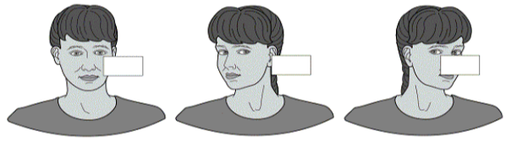

How to vary and progress the exercise difficulty

- Do the exercises in sitting
- Do the exercises in standing with your feet ............cm apart
- Practice this exercise at different speeds of head movement (slow, medium, fast)
- Repeat the exercise moving your head up and down for 1-2 minutes
- Repeat the exercises using a large pattern in the background such as a checkerboard, wallpaper or television.
- First, move your head from side to side for 1-2 minutes. Rest briefly. Then move your head vertically for 1-2 minutes.
- First try with the business card close to you, then with the business card further across the room.

Visual fixation on a moving target
Hold the card in your hand, move the card and your head horizontally (from side to side) in opposite directions for 1-2 minutes keeping the word in focus all the time.
In other words when your head moves to the right, the card should move to the left, and when your head moves to the left, the card should move to the right.

References
http://www.mccc.edu/~behrensb/documents/VestibularRehabilitationTherapy.pdf
[online 11/06/2014]
http://visionhelp.files.wordpress.com/2011/12/gaze-stabilization-exercises.gif [online 11/06/2014]

Contact details
Outpatients Physiotherapy

Telephone number 01202 442121

For further general health-related information, please ask the relevant department for an Information Prescription or contact:

The Health Information Centre
Poole Hospital NHS Foundation Trust
Longfleet Road
Poole

Dorset
BH15 2JB
Telephone: 01202 448003

www.poole.nhs.uk

Author: Ian Kennedy Elaine Dechow Jackie Kidd Andy Hayward
Date: 11/06/2014
Review date: Ongoing
Version number:

We can supply this information in other formats, in larger print, on audiotape, or have it translated for you. Please call the Patient Advice and Liaison Service (PALS) on 01202 448499, text 07758 272495 or email pals@poole.nhs.uk for advice.

If you wish to make any comments or to ask about any research evidence used to write this leaflet, please contact the Patient Information Team confidentially: phone 01202 448003, write to the Health Information Centre (address above), or email patient.information@poole.nhs.uk.

