Epley Maneuver for posterior canal BPPV

Particle repositioning head manoeuvres are considered to be more effective than medication or other forms of exercise-based therapy in treating posterior canal BPPV. However, even with successful treatment with such manoeuvres, BPPV recurs in about one-third of patients after one year, and in about 50% of all patients treated after five years.

The canalith repositioning procedure (CRP) is the most common and empirically proven treatment for posterior canal BPPV. Also called the Epley manoeuvre or the modified liberatory manoeuvre, CRP involves sequential movement of the head into four positions, with positional shifts spaced roughly 30 seconds apart. Differing opinions exist about the benefits of using mastoid vibration during CRP, with a recent evidence-based research review suggesting that it probably does not benefit patients.

Left posterior canal affected

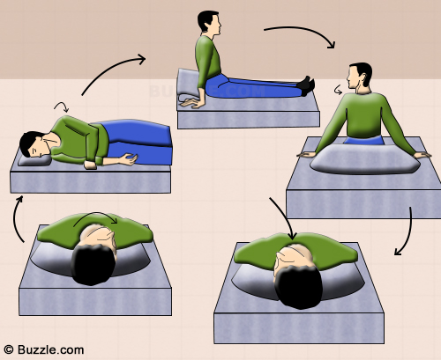

Sit upright and position your head to the symptomatic side at an angle of 45°, and lie down on your back.

Remain in this position for at least 5 minutes and then turn your head at an angle of 90° to the other side.

Remain in this position for another 5 minutes and turn your body onto your side with your face pointing downwards.

After being in this position for 5 minutes, go back to your sitting position and remain in that position for nearly 30 seconds.

Repeat the exercise 2-3 times more, and relax.

References

http://vestibular.org/understanding-vestibular-disorders/types-vestibular-disorders/benign-paroxysmal-positional-vertigo

http://www.buzzle.com/articles/positional-vertigo-exercises.html

