Hand Therapy 
Patient Information

De Quervain’s

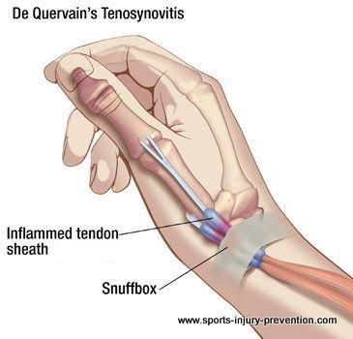
What is De Quervain’s?
De Quervain’s is a temporary thickening and narrowing of an area called the first dorsal compartment at the base of the thumb. Two tendons travel through this compartment: the extensor pollicis brevis (EPB) and the abductor pollicis longus (APL).

What are the symptoms of De Quervain’s?
- Pain and tenderness at the side of the wrist beneath the base of the thumb
- Pain on moving the thumb and wrist
- Pain during functional use of the hand and wrist

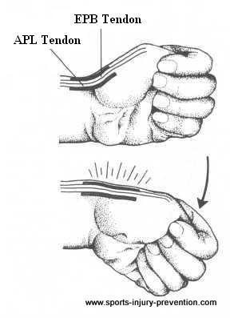
How is De Quervain’s treated?
Treatments for De Quervain’s include these options:

- Steroid injection with or without a thumb and wrist splint for 2 weeks +/- activity modification. This is recommended as the best first line management for the condition and has a success rate of approx. 74% with 2 injections.
- Use of a thumb/wrist splint only for 6 weeks +/- activity modification
- Surgery to release the tendons

*Images reproduced with kind permission of Arthritis Research UK: http://www.arthritisresearchuk.org/
plinting
- Ideally splints are custom made by a hand therapist, your GP can refer you
- They are used to prevent repetitive use of your wrist and enable the tendons to rest and to reduce pain while you are using your hand and wrist
- Your splint should be discarded after 6 weeks use and gradually increase in the use of your hand
- A hand therapist can help you with ergonomic advice and activity modification

Activity modification
Avoid using your thumb in a wide span combined with a wrist that is very flexed towards the palm, especially for prolonged periods of time. Opening jars, lifting a small child, piano playing are examples of activities that may make pain worse.
Repetitive thumb movements e.g. texting or using a gaming console can be aggravating too.

Range of movement exercises
Some gentle motion is helpful to keep the tendons from getting stiff and deconditioned.
Remove your splint to do the exercises a few times a day ensuring they are done within a comfortable range, i.e. they should not be painful. Repeat 5-10 times as comfort allows.
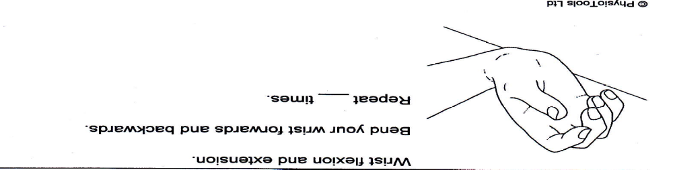

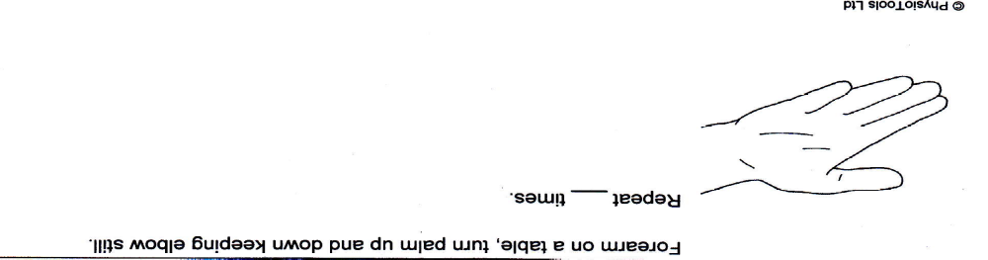

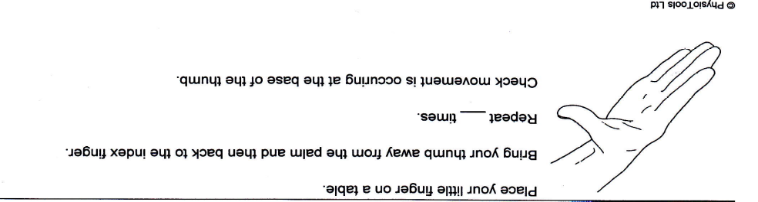

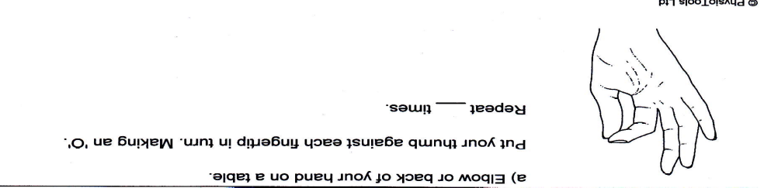

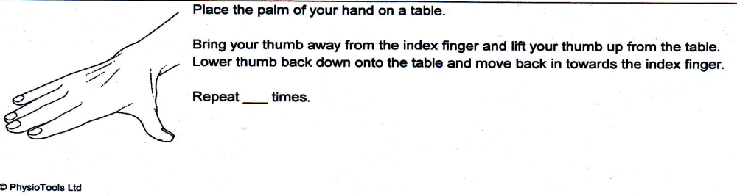

Reproduced with kind permission of Physio Tools Ltd.

If further intervention is required

- If there is no improvement following hand therapy or a steroid injection, your GP can make a referral for a surgical opinion.

References

Cavaleri R, et al. (2016) Hand therapy versus corticosteroid injections in the treatment of de Quervain’s disease: A systematic review and meta-analysis. Journal of Hand Therapy (29) 3-11
Consensus on a Multidisciplinary Treatment Guideline for de Quervain Disease: Results From the European HANDGUIDE Study Bionka M.A. Huisstede, J. Henk Coert, Jan Fridén and Peter Hoogvliet Physical Therapy. 2014; 94:1095-1110.

Effectiveness of Corticosteroid Injections for Treatment of de Quervain’s Tenosynovitis
Jinhee K. HAND 2017, Vol. 12(4) 357–361
.

Contact details
Hand Therapy Team, Therapy Services Department: 01202 442121

For further general health-related information, please ask the relevant department for an Information Prescription or contact:

The Health Information Centre
Poole Hospital NHS Foundation Trust
Longfleet Road
Poole
Dorset
BH15 2JB
Telephone: 01202 448003

Author: Sarah Bradley
Date: Oct 2019
Version Number: 2
Ward sister/HOD: Hilary Hall

We can supply this information in larger print, on audiotape, or have it translated for you. Please call the Patient Advice and Liaison Service (PALS) on 01202 448499 or the Health Information Centre on 01202 448003 for further advice.

