Brandt-Daroff
Habituation
This exercise is usually tried when the Semont or modified Epley maneuvers are not effective

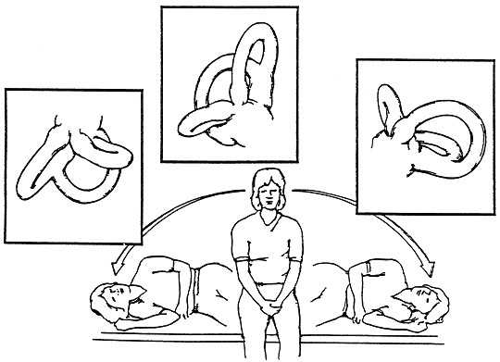

- Sit straight on the edge of the bed and turn your head slightly to the left side at an angle of 45°.
- Lie down quickly on your back to the right side and remain in this position for 20 - 30 seconds or until the dizziness resolves.
- Sit up straight and again wait in this position for 20 - 30 seconds or until the dizziness resolves.
- Now turn your head slightly to right side and lie down quickly on your back to the left side.
- Remain in this position for another 20 - 30 seconds and then sit upright, and repeat the procedure three times.

References
http://www.crashingpatient.com/wp-content/images/part1/vertigoexercises.gif [online 11/06/2014]

Contact details
Outpatients Physiotherapy

Telephone number 01202 442121

For further general health-related information, please ask the relevant department for an Information Prescription or contact:

The Health Information Centre
Poole Hospital NHS Foundation Trust
Longfleet Road
Poole

Dorset
BH15 2JB
Telephone: 01202 448003

www.poole.nhs.uk

Author: Ian Kennedy Elaine Dechow Jackie Kidd Andy Hayward
Date: 11/06/2014
Review date: Ongoing
Version number:

We can supply this information in other formats, in larger print, on audiotape, or have it translated for you. Please call the Patient Advice and Liaison Service (PALS) on 01202 448499, text 07758 272495 or email pals@poole.nhs.uk for advice.

If you wish to make any comments or to ask about any research evidence used to write this leaflet, please contact the Patient Information Team confidentially: phone 01202 448003, write to the Health Information Centre (address above), or email patient.information@poole.nhs.uk.

